**Supplementary information**

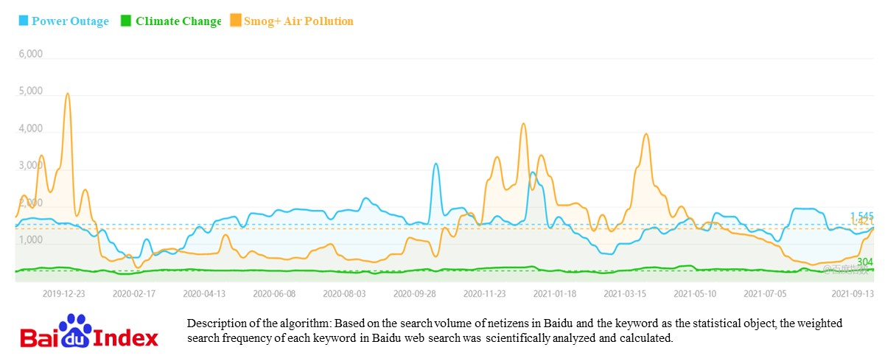

Figure S1. Baidu keywords search index trends between three keywords: power outage, smog and air pollution, and climate change. Notes: The solid line represents the Baidu index, and the dashed line represents the mean. The time range is November 2019 to September 2021.

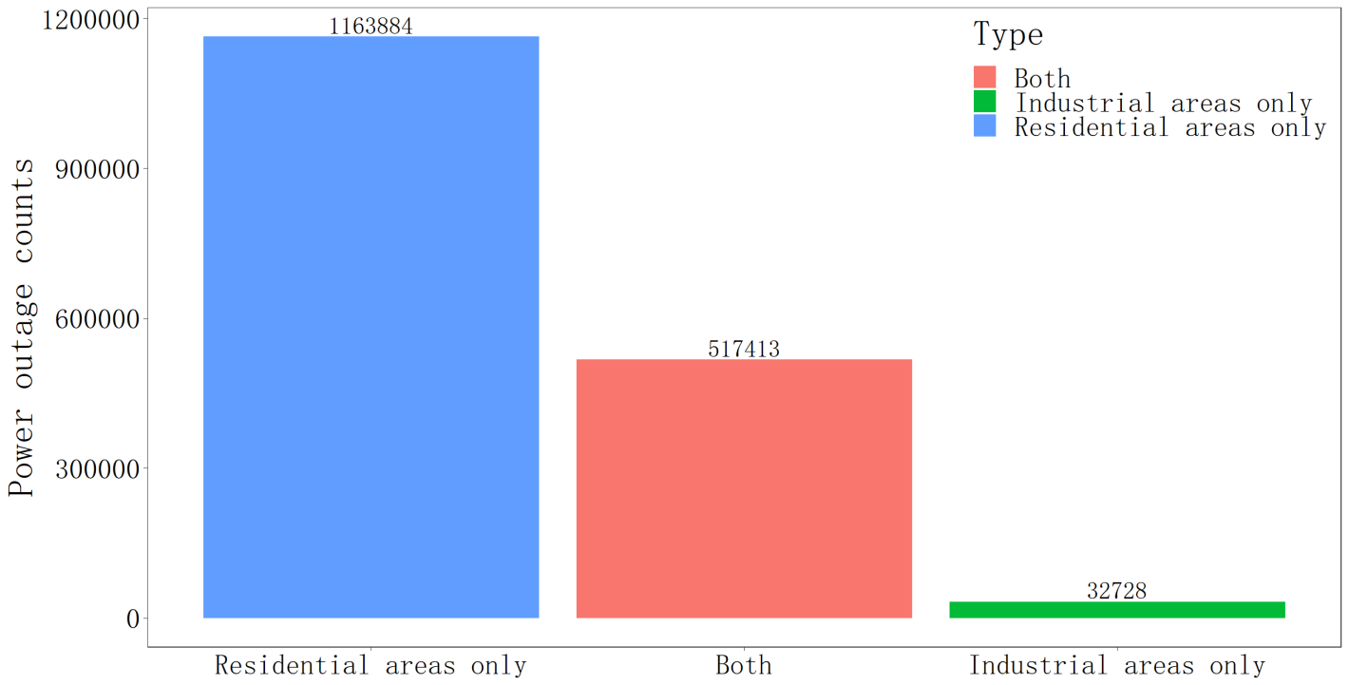

Figure S2. The distribution of power outages in residential versus industrial areas in our dataset.

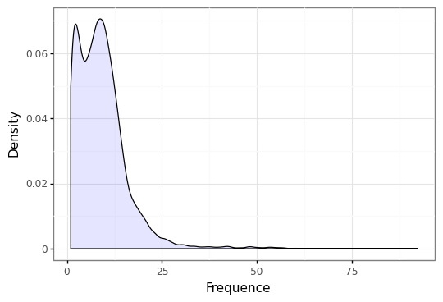

(a) All EV types

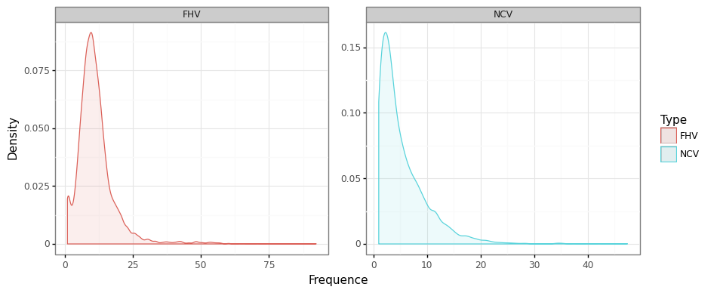

(b) By FHV (for-hire vehicles) and NCV (non-commercial vehicles)

Figure S3. The density plot of the weekly charging frequency of EVs.

Figure S4. Attitudes reported by respondents in response to the statement on the impact of power outage exposure on EV purchasing intention. Notes: The survey question is “Do you agree with the following statement: Extended power outages or increasing frequencies of power outages will reduce your willingness to purchase EVs”.

Table S1. Descriptive statistics

|  |  |  |  |  |  |
| --- | --- | --- | --- | --- | --- |
| Variables | (1) | (2) | (3) | (4) | (5) |
| obs | mean | sd | min | max |
| NEV (BEV+plug-in HEV) | 6945 | 404.48 | 1374.02 | 0 | 31489 |
| BEV | 6945 | 343.61 | 1070.60 | 1 | 19713 |
| PHEV (plug-in HEV) | 6945 | 60.93 | 367.23 | 0 | 12599 |
| NCV | 6945 | 448.70 | 1356.86 | 0 | 32279 |
| FHV | 6945 | 61.18 | 247.82 | 0 | 4570 |
| Non-EV | 6945 | 1540.69 | 4370.00 | 1 | 65191 |
| Outage times | 6945 | 10.19 | 15.14 | 0 | 155.56 |
| Outage hours | 6945 | 103.24 | 252.04 | 0 | 12561.7 |

Table S2. Regression results with EV charging station added as a control variable

|  |  |  |  |  |  |  |
| --- | --- | --- | --- | --- | --- | --- |
|  | EV sales | | | | | |
|  | (1) | (2) | (3) | (4) | (5) | (6) |
|  | ln(BEV+ PHEV) | ln(BEV+PHEV) | lnBEV | lnBEV | ln PHEV | ln PHEV |
| L1.Outage times | -0.0099*** |  | -0.0085*** |  | -0.013*** |  |
|  | (0.001) |  | (0.001) |  | (0.003) |  |
| L1.Outage hours |  | -0.0002** |  | -0.0002** |  | -0.0003* |
|  |  | (0.0001) |  | (0.0001) |  | (0.0002) |
| ln(Charging station) | -1.35** | -1.51** | -1.38* | -1.51** | -2.46*** | -2.66*** |
|  | (0.53) | (0.71) | (0.71) | (0.73) | (0.69) | (0.71) |
| ln(GDP) | -0.047* | -0.050* | -0.030 | -0.032 | -0.057 | -0.060 |
|  | (0.025) | (0.026) | (0.025) | (0.025) | (0.039) | (0.040) |
| Constant | 17.68*** | 19.06*** | 17.64*** | 18.83*** | 26.21*** | 28.01*** |
|  | (6.56) | (6.80) | (6.83) | (7.01) | (6.57) | (4.11) |
| Year*City FE | YES | YES | YES | YES | YES | YES |
| Month*City FE | YES | YES | YES | YES | YES | YES |
| Number of observations | 4700 | 4700 | 4700 | 4700 | 4700 | 4700 |
| Number of city | 301 | 301 | 301 | 301 | 301 | 301 |
| R-squared | 0.90 | 0.90 | 0.91 | 0.90 | 0.74 | 0.73 |

Note: Standard errors in parentheses are clustered to city level. *P< 0.1, **P< 0.05, ***P< 0.01. R-squared denotes the goodness-of-fit of the regressions. The variable lncp is the natural log of the provincial level EV charging stations available of a given month divided by the number of cities of the province. The EV charging station data comes from the China Electric Vehicle Charging Infrastructure Promotion Alliance (http://www.evcipa.org.cn/).

Table S3. Regression results of the heterogeneity analysis by vehicle type. Note that due to data limitations, we cannot distinguish plug-in versus non-plug-in EVs by vehicle type. The analysis in this tale includes BEV, PHEV, and non-plug-in EV.

|  |  |  |  |  |
| --- | --- | --- | --- | --- |
|  | EV sales | | | |
|  | lnNCV (non-commercial, private vehicle) | | lnFHV (For-hire vehicle) | |
|  | (1) | (2) | (3) | (4) |
| *One-month lag results* |  |  |  |  |
| L1.Outage times | -0.010*** |  | -0.002 |  |
|  | (0.001) |  | (0.002) |  |
| L1.Outage hours |  | -0.00019** |  | -0.00003 |
|  |  | (0.00009) |  | (0.0001) |
| ln(GDP) | -0.028 | -0.030 | -0.019 | -0.019 |
|  | (0.027) | (0.028) | (0.035) | (0.035) |
| Constant | 5.00*** | 4.92*** | 1.70** | 1.68*** |
|  | (0.23) | (0.23) | (0.29) | (0.29) |
| Number of observations | 4700 | 4700 | 4700 | 4700 |
| Number of city | 301 | 301 | 301 | 301 |
| R-squared | 0.95 | 0.94 | 0.93 | 0.93 |
| *Two-month lag results* |  |  |  |  |
| L1.Outage times | -0.004*** |  | -0.0009 |  |
|  | (0.001) |  | (0.002) |  |
| L1.Outage hours |  | -0.00006 |  | -0.00001 |
|  |  | (0.00007) |  | (0.0001) |
| L2.Outage times | -0.004*** |  | -0.004* |  |
|  | (0.001) |  | (0.002) |  |
| L2.Outage hours |  | -0.000007 |  | -0.00009 |
|  |  | (0.00005) |  | (0.0001) |
| ln(GDP) | -0.047** | -0.047** | -0.015 | -0.017 |
|  | (0.020) | (0.020) | (0.038) | (0.038) |
| Constant | 5.32*** | 5.24*** | 1.84*** | 1.80*** |
|  | (0.16) | (0.17) | (0.32) | (0.32) |
| Number of observations | 4090 | 4090 | 4090 | 4090 |
| Number of city | 298 | 298 | 298 | 298 |
| R-squared | 0.92 | 0.92 | 0.83 | 0.82 |
| Year*City FE | YES | YES | YES | YES |
| Month*City FE | YES | YES | YES | YES |

Note: Standard errors in parentheses are clustered to city level. *P< 0.1, **P< 0.05, ***P< 0.01. R-squared denotes the goodness-of-fit of the regressions.

Table S4. Regression results of the heterogeneity analysis by region and GDP

|  |  |  |  |  |  |  |  |  |  |  |  |
| --- | --- | --- | --- | --- | --- | --- | --- | --- | --- | --- | --- |
|  | ln BEV+plug in HEV | | | | | | | | | | |
| Southern provinces | | | Northern provinces | | | Low per_GDP | | High per_GDP | | |
| (1) | (2) | (3) | | (4) | (5) | | (6) | | (7) | (8) |
| One-month lag |  |  |  | |  |  | |  | |  |  |
| L1.Outage times | -0.0096***  (0.001) |  | -0.014***  (0.003) | |  | -0.014***  (0.003) | |  | | -0.009***  (0.001) |  |
| L1.Outage hours |  | -0.00004  (0.0001) |  | | -0.0006***  (0.0001) |  | | -0.0004***  (0.0001) | |  | -0.00006  (0.0001) |
| ln(GDP) | -0.012  (0.035) | -0.011  (0.036) | -0.076*  (0.041) | | -0.082**  (0.041) | -0.072**  (0.035) | | -0.075**  (0.035) | | -0.006  (0.041) | -0.008  (0.042) |
| Constant | 4.81***  (0.29) | 4.66***  (0.30) | 4.40***  (0.34) | | 4.40***  (0.34) | 4.31***  (0.29) | | 4.28***  (0.29) | | 5.08***  (0.34) | 4.94***  (0.35) |
| Number of observations | 2574 | 2574 | 2126 | | 2126 | 2656 | | 2656 | | 2044 | 2044 |
| Number of city | 162 | 162 | 139 | | 139 | 173 | | 173 | | 128 | 128 |
| R-squared | 0.96 | 0.96 | 0.96 | | 0.96 | 0.96 | | 0.96 | | 0.96 | 0.96 |
| Two-month lag |  |  |  | |  |  | |  | |  |  |
| L1.Outage times | -0.004***  (0.001) |  | -0.012***  (0.003) | |  | -0.011***  (0.002) | |  | | -0.004***  (0.001) |  |
| L1.Outage hours |  | 0.00006  (0.0009) |  | | -0.0004***  (0.0001) |  | | -0.0003***  (0.0001) | |  | 0.00002  (0.0001) |
| L2.Outage times | -0.008***  (0.001) |  | -0.013***  (0.003) | |  | -0.017***  (0.003) | |  | | -0.006***  (0.001) |  |
| L2.Outage hours |  | -0.00014  (0.0009) |  | | -0.0003**  (0.0001) |  | | -0.0003**  (0.0001) | |  | -0.0001  (0.0001) |
| ln(GDP) | -0.022  (0.027) | -0.203  (0.029) | -0.073**  (0.038) | | -0.082**  (0.037) | -0.072**  (0.034) | | -0.077**  (0.034) | | -0.018  (0.029) | -0.017  (0.031) |
| Constant | 5.15***  (0.23) | 4.97***  (0.24) | 4.68***  (0.31) | | 4.63***  (0.31) | 4.62***  (0.28) | | 4.53***  (0.29) | | 5.41***  (0.24) | 5.24***  (0.25) |
| Number of observations | 2246 | 2246 | 1844 | | 1844 | 2302 | | 2302 | | 1788 | 1788 |
| Number of city | 161 | 161 | 137 | | 137 | 170 | | 170 | | 128 | 128 |
| R-squared | 0.93 | 0.92 | 0.93 | | 0.93 | 0.92 | | 0.92 | | 0.93 | 0.93 |
| Year*City FE | YES | YES | YES | | YES | YES | | YES | | YES | YES |
| Month *City FE | YES | YES | YES | | YES | YES | | YES | | YES | YES |

Table S5. Test for statistical significance of the difference between regions and GDP levels

|  |  |  |  |  |
| --- | --- | --- | --- | --- |
|  | ln BEV+plug in HEV | | | |
|  | (1) | (2) | (3) | (4) |
| L1.Outage times*High GDP | 0.005  (0.003) |  |  |  |
| L1.Outage hours*High GDP |  | 0.0004**  (0.0002) |  |  |
| L1.Outage times *South |  |  | 0.005  (0.004) |  |
| L1.Outage hours *South |  |  |  | 0.0005***  (0.0001) |
| L1.Outage times | -0.014***  (0.003) |  | -0.014***  (0.003) |  |
| L1.Outage hours |  | -0.0004***  (0.0001) |  | -0.0006***  (0.0001) |
| ln(GDP) | -0.042 | -0.044 | -0.041 | -0.043 |
|  | (0.027) | (0.027) | (0.026) | (0.027) |
| Constant | 4.63*** | 4.55*** | 4.63*** | 4.54*** |
|  | (0.22) | (0.22) | (0.22) | (0.22) |
| Year*City FE | YES | YES | YES | YES |
| Month*City FE | YES | YES | YES | YES |
| Number of observations | 4700 | 4700 | 4700 | 4700 |
| Number of city | 301 | 301 | 301 | 301 |
| R-squared | 0.96 | 0.98 | 0.96 | 0.96 |

Table S6. Regression results with no lag and a three-month lag of power outages

|  |  |  |  |  |
| --- | --- | --- | --- | --- |
|  | ln (BEV+PHEV) | | | |
|  | 0-month lag | 3-month lag | 0-month lag | 3-month lag |
|  | (1) | (2) | (3) | (4) |
| Outage times | 0.0013  (0.0012) |  |  |  |
| Outage hours |  |  | -0.00004  (0.00005) |  |
| L1.Outage times |  | -0.0057***  (0.001) |  |  |
| L1.Outage hours |  |  |  | -0.0002**  (0.00008) |
| L2.Outage times |  | -0.0080***  (0.001) |  |  |
| L2.Outage hours |  |  |  | -0.0002***  (0.00007) |
| L3.Outage times |  | -0.0004  (0.001) |  |  |
| L3.Outage hours |  |  |  | 0.000006  (0.0001) |
| ln(GDP) | -0.043*  (0.023) | -0.049**  (0.022) | -0.044*  (0.023) | -0.049**  (0.022) |
| ln (charging station) | -0.99**  (0.40) | -0.22  (0.51) | -0.99**  (0.41) | -0.30  (0.52) |
| Constant | 13.85***  (3.85) | 7.19  (4.87) | 13.96***  (3.86) | 7.82  (5.03) |
| R-squared | 0.97 | 0.98 | 0.97 | 0.98 |
| Year*City FE | YES | YES | YES | YES |
| Month*City FE | YES | YES | YES | YES |
| Number of observations | 6304 | 3492 | 6304 | 3492 |
| Number of city | 304 | 297 | 304 | 297 |

Table S7. Regression results of four model specifications

|  |  |  |  |  |  |  |  |  |
| --- | --- | --- | --- | --- | --- | --- | --- | --- |
|  | Linear | | Semi-log | | Double-log | Exponential | | |
|  | NEV | lnNEV | | lnNEV | | | | NEV |
|  | (1) | (2) | | (3) | | | (4) | |
| L1.Outage times | 0.88 | -0.0088*** | |  | | |  | |
|  | (0.67) | (0.001) | |  | | |  | |
| ln(L1.Outage times) |  |  | | -0.071*** | | |  | |
|  |  |  | | (0.017) | | |  | |
| $$e^{l1.Outage times}$$ |  |  | |  | | | -2.49e-65*** | |
|  |  |  | |  | | | (3.19e-67) | |
| lnGDP | 9.75 | -0.047** | | -0.047* | | | 9.41 | |
|  | (19.26) | (0.023) | | (0.025) | | | (19.24) | |
| Constant | 373.87** | 4.85*** | | 4.87*** | | | 386.96*** | |
|  | (159.45) | (0.19) | | (0.21) | | | (159.49) | |
| Number of observations | 4130 | 4130 | | 3560 | | | 4130 | |
| Number of city | 300 | 300 | | 284 | | | 300 | |
| R-squared | 0.97 | 0.98 | | 0.96 | | | 0.97 | |
| F | 1.04 | 25.91 | | 10.17 | | | 3.68e+09 | |
| Year*City FE | YES | YES | | YES | | | YES | |
| Month*City FE | YES | YES | | YES | | | YES | |

Notes: Standard errors in parentheses; ***, **，* indicate statistical significance at 1%, 5%, and 10% levels, respectively. NEV= battery electric vehicles BEV+plug-in hybrid PHEV.

Table S8. Link test results

|  |  |  |  |  |  |  |
| --- | --- | --- | --- | --- | --- | --- |
|  | Linear | Semi-log | | Double-log | Exponential | |
|  | (1) | (2) | (3) | | | (4) |
| $${\hat{y}}^{2}$$ | -0.027 | -0.82 | 4.06*** | | | 0.0067** |
|  | (0.030) | (0.533) | (1.540) | | | (0.003) |

Notes: ***, **，* indicate statistical significance at 1%, 5%, and 10% levels, respectively. Standard errors are in parentheses.

Table S9. Panel unit root test results

|  |  |  |  |  |
| --- | --- | --- | --- | --- |
|  | HT (Harris and Tzavalis) | H0：Panels contain unit roots | IPS (Im, Pesaran, and Shin) | H0：Panels contain unit roots |
| lnBPHEV | 0.76***  (0.00) | Reject | -5.71***  (0.00) | Reject |
| lnBEV | 0.73***  (0.00) | Reject | -3.49***  (0.00) | Reject |
| lnPHEV | 0.71***  (0.00) | Reject | -3.43***  (0.00) | Reject |
| Outage times | 0.22***  (0.00) | Reject | -6.91***  (0.00) | Reject |
| Outage hours | 0.07***  (0.00) | Reject | -6.26***  (0.00) | Reject |
| lnGDP | 0.63***  (0.00) | Reject | -5.81***  (0.00) | Reject |
| ln(charging station) | 0.99  (1.00) | Support | 17.09  (1.00) | Support |
| d.ln(charging station) | -0.121***  (0.00) | Reject | -6.91***  (0.00) | Reject |

Notes: P-values in parentheses; ***, **，* indicate statistical significance at 1%, 5%, and 10% levels, respectively. BPHEV includes both battery electric vehicles and plug-in hybrid electric vehicles.

Table S10. Regression results with EV charging station (first difference) added as a control variable

|  |  |  |  |
| --- | --- | --- | --- |
|  | d.LnNEV(BEV+PHEV) | d.LnBEV | d.LnPHEV |
|  | (1) | (2) | (3) |
| L1.( d.Outage times) | -0.003***  (0.001) | -0.003**  (0.001) | -0.007***  (0.002) |
| L2.( d.Outage times) | -0.008***  (0.001) | -0.007***  (0.002) | -0.02***  (0.003) |
| d.lnGDP | -0.088***  (0.032) | -0.073**  (0.026) | -0.041  (0.045) |
| d.ln(Charging station) | -0.78  (0.49) | -0.65  (0.57) | -0.45  (0.66) |
| Constant | 0.23***  (0.02) | 0.20***  (0.02) | 0.34***  (0.02) |
| Year*City FE | YES | YES | YES |
| Month*City FE | YES | YES | YES |
| Number of observations | 2616 | 2616 | 2616 |
| Number of city | 218 | 218 | 218 |
| R-squared | 0.57 | 0.55 | 0.56 |

Notes: Standard errors in parentheses; ***, **，* indicate statistical significance at 1%, 5%, and 10% levels, respectively. d.ln(Charging station) is the first difference of ln(Charging station).

Table S11. Panel cointegration test results

|  |  |  |  |  |
| --- | --- | --- | --- | --- |
|  | Test | Statistic | P-value | H0: No cointegration |
| Pedroni | Modified Phillips-Perron | 2.1982 | 0.0140 | Reject |
|  | Phillips-Perron | -28.9113 | 0.0000 | Reject |
|  | Augmented Dickey-Fuller | -38.0090 | 0.0000 | Reject |
| Kao | Modified Dickey-Fuller | -2.0532 | 0.0200 | Reject |
|  | Dickey-Fuller | -14.2304 | 0.0000 | Reject |
|  | Augmented Dickey-Fuller | -2.0242 | 0.0215 | Reject |
|  | Unadjusted modified Dickey-Fuller | -47.3051 | 0.0000 | Reject |
|  | Unadjusted Dickey-Fuller | -37.9558 | 0.0000 | Reject |

Table S12. Granger non-causality test for the impact of EV sales on power outages

|  |  |  |  |
| --- | --- | --- | --- |
|  | Statistic | P-value | Test result |
| lnBPHEV does not Granger-cause outaget | 0.2689 | 0.7880 | Support |
| lnBEV does not Granger-cause outaget | 1.4045 | 0.1602 | Support |
| lnPHEV does not Granger-cause outaget | 1.0044 | 0.3152 | Support |
| lnBPHEV does not Granger-cause outageh | -0.7011 | 0.4833 | Support |
| lnBEV does not Granger-cause outageh | -0.7473 | 0.4549 | Support |
| lnPHEV does not Granger-cause outageh | 0.0713 | 0.9431 | Support |

Table S13. Granger non-causality test for the impact of power outages on EV sales

|  |  |  |  |
| --- | --- | --- | --- |
|  | Statistic | P-value | Test result |
| outaget does not Granger-cause lnBPHEV. | 4.1981 | 0.0000 | Reject |
| outaget does not Granger-cause lnBEV | 2.6127 | 0.0090 | Reject |
| outaget does not Granger-cause lnPHEV | 3.6851 | 0.0000 | Reject |
| outageh does not Granger-cause lnBPHEV. | 4.0245 | 0.0001 | Reject |
| outageh does not Granger-cause lnBEV | 2.7938 | 0.0052 | Reject |
| outageh does not Granger-cause lnPHEV | 3.5952 | 0.0001 | Reject |

Table S14. Results of models adding the mandatory notice variable

|  |  |  |  |
| --- | --- | --- | --- |
|  | LnNEV(BEV+PHEV) | LnBEV | LnPHEV |
|  | (1) | (2) | (3) |
| L1.Outage times | -0.010***  (0.001) | -0.009***  (0.001) | -0.014***  (0.003) |
| lnGDP | -0.041  (0.027) | -0.023  (0.026) | -0.046  (0.040) |
| L1.Mandatory notices | -0.48***  (0.14) | -0.43***  (0.13) | -0.58***  (0.28) |
| Constant | 4.63***  (0.22) | 4.31***  (0.21) | 2.47***  (0.34) |
| Year*City FE | YES | YES | YES |
| Month*City FE | YES | YES | YES |
| Number of observations | 4700 | 4700 | 4700 |
| Number of city | 301 | 301 | 301 |
| R-squared | 0.96 | 0.96 | 0.90 |
| Note: Similar to the lagged term of power outages, we also use a lagged term of the mandatory notice in the models. | | | |

Notes: Standard errors in parentheses; ***, **，* indicate statistical significance at 1%, 5%, and 10% levels, respectively.

Table S15. Regression results of models adding supply chain disruption and COVID restriction variables

|  |  |  |  |  |
| --- | --- | --- | --- | --- |
|  | lnNEV (BEV+PHEV) | | | |
|  | (1) | (2) | (3) | (4) |
|  | One-month lag | Two-month lag | One-month lag | Two-month lag |
| L1.Outage times | -0.0060***  (0.0011) | -0.004***  (0.001) |  |  |
| L1.Outage hours |  |  | -0.00019**  (0.00008) | -0.00016**  (0.00008) |
| L2.Outage times |  | -0.007***  (0.001) |  |  |
| L2.Outage hours |  |  |  | -0.00019***  (0.00006) |
| lnGDP | -0.029  (0.019) | -0.038*  (0.019) | -0.029  (0.019) | -0.038*  (0.020) |
| COVID restrictions | -0.74***  (0.052) | -0.33***  (0.051) | -0.74***  (0.052) | -0.34***  (0.050) |
| Disruptions in vehicle supply | -0.30***  (0.040) | -0.29***  (0.041) | -0.32***  (0.040) | -0.31***  (0.041) |
| Constant | 4.62***  (0.16) | 4.89***  (0.16) | 4.59***  (0.16) | 4.81***  (0.16) |
| Year*City FE | YES | YES | YES | YES |
| Month*City FE | YES | YES | YES | YES |
| Number of observations | 4700 | 4090 | 4700 | 4090 |
| Number of city | 301 | 298 | 301 | 298 |
| R-squared | 0.97 | 0.98 | 0.97 | 0.98 |

Notes: Standard errors in parentheses; ***, **，* indicate statistical significance at 1%, 5%, and 10% levels, respectively.

Table S16. Estimation results with instrumental variable (using outage times as the explanatory variable).

|  |  |  |  |  |  |  |  |
| --- | --- | --- | --- | --- | --- | --- | --- |
|  | lnNEV(BEV+PHEV) | | lnBEV | | lnPHEV | | |
|  | (1) | (2) | (3) | (4) | (5) | | (6) |
|  | IV, first stage | IV, second stage | IV, first stage | IV, second stage | IV, first stage | IV, second stage | |
| L1.(DD) | -0.33***  (0.033) |  | -0.33***  (0.033) |  | -0.33***  (0.033) |  | |
| L1.(outage times) |  | -0.13***  (0.014) |  | -0.11***  (0.013) |  | -0.16***  (0.018) | |
| ln (GDP) | 0.18  (0.28) | -0.023  (0.040) | 0.18  (0.28) | -0.008  (0.036) | 0.18  (0.28) | -0.020  (0.052) | |
| Year*City FE | YES | YES | YES | YES | YES | YES | |
| Month*City FE | YES | YES | YES | YES | YES | YES | |
| Observations | 4604 | 4604 | 4604 | 4604 | 4604 | 4604 | |
| Stock-Yogo weak ID test | 16.38 |  | 16.38 |  | 16.38 |  | |
| F Statistics | 99.38 |  | 99.38 |  | 99.38 |  | |

Note: Numbers in [] are the Stock-Yogo weak ID test critical values at 10% level; the value of F statistics shows the F test of excluded instruments; numbers in () are standard errors of the coefficients.

Table S17. Estimation results with instrumental variable (using outage hours as the explanatory variable).

|  |  |  |  |  |  |  |
| --- | --- | --- | --- | --- | --- | --- |
|  | lnNEV(BEV+PHEV) | | lnBEV | | lnPHEV | |
|  | (1) | (2) | (3) | (4) | (5) | (6) |
|  | IV, first stage | IV, second stage | IV, first stage | IV, second stage | IV, first stage | IV, second stage |
| L1. (DD) | -2.13***  (0.45) |  | -2.13***  (0.45) |  | -2.13***  (0.45) |  |
| L1.(outage hours) |  | -0.020***  (0.004) |  | -0.018***  (0.004) |  | -0.025***  (0.005) |
| ln (GDP) | 1.52  (4.55) | -0.016  (0.092) | 1.52  (4.55) | -0.002  (0.081) | 1.52  (4.55) | -0.011  (0.12) |
| Year*City FE | YES | YES | YES | YES | YES | YES |
| Month*City FE | YES | YES | YES | YES | YES | YES |
| Observations | 4604 | 4604 | 4604 | 4604 | 4604 | 4604 |
| Stock-Yogo weak ID test | 16.38 |  | 16.38 |  | 16.38 |  |
| F statistics | 22.94 |  | 22.94 |  | 22.94 |  |

Note: Numbers in [] are the Stock-Yogo weak ID test critical values at 10% level; the value of F statistics shows the F test of excluded instruments; numbers in () are standard errors of the coefficients.

Table S18. Regression results with per capita EV sales and per capita power outage

|  |  |  |  |  |  |
| --- | --- | --- | --- | --- | --- |
|  | per capita sales | | | | |
|  | ln (per capita NEV) | | ln (per capita BEV) | |
|  | (1) | (2) | (3) | (4) |
| per capita outage times | 0.36  (0.54) |  | 0.27  (0.29) |  |
| per capita outage hours |  | -0.035  (0.036) |  | -0.005  (0.011) |
| L1. (per capita outage times) | -1.01**  (0.41) |  | -0.77***  (0.20) |  |
| L1. (per capita outage hours) |  | -0.051  (0.035) |  | -0.013  (0.015) |
| L2. (per capita outage times) | -1.41*** |  | -1.82*** |  |
| (0.46) |  | (0.39) |  |
| L2. (per capita outage hours) |  | -0.001 |  | -0.036** |
|  | (0.019) |  | (0.018) |
| ln (GDP) | -0.019 | -0.020 | -0.026 | -0.027 |
|  | (0.027) | (0.027) | (0.022) | (0.023) |
| Constant | -1.08*** | -1.10*** | -1.26*** | -1.31** |
|  | (0.22) | (0.22) | (0.19) | (0.19) |
| Year*City FE | YES | YES | YES | YES |
| Month*City FE | YES | YES | YES | YES |
| Number of observations | 3776 | 3776 | 3776 | 3776 |
| Number of city | 272 | 272 | 272 | 272 |
| R-squared | 0.92 | 0.92 | 0.97 | 0.97 |

Note: Standard errors in parentheses are clustered to city level. *P< 0.1, **P< 0.05, ***P< 0.01. R-squared denotes the goodness-of-fit of the regressions.

Table S19. Regression results of the impact of power outages on the economy.

|  |  |  |  |  |  |
| --- | --- | --- | --- | --- | --- |
|  | ln(Industrial value added) | | | ln(GDP) | |
| outage times | -0.00004  (0.00008) |  | -0.0012  (0.0017) | |  |
| outage hours |  | -2.24e-06  (2.93e-06) |  | | -0.00009  (0.0006) |
| Constant | 15.85***  (0.006) | 15.85***  (0.006) | 8.31***  (0.018) | | 8.31***  (0.018) |
| R-squared | 0.52 | 0.82 | 0.82 | | 0.82 |
| Time FE | YES | YES | YES | | YES |
| City FE | YES | YES | YES | | YES |
| Number of observations | 6255 | 6255 | 6304 | | 6304 |
| Number of cities | 283 | 283 | 304 | | 304 |

|  |  |  |  |
| --- | --- | --- | --- |
| Table S20. Between-group Difference Test | | | |
|  | BEV | PHEV | T-statistic (P-value） |
| l1.Outaget | -0.0092 | -0.014 | 1.49 (0.14) |
| l1.Outageh | -0.0002 | -0.0003 | 0.42 (0.67) |
| We used T-test to whether PHEV may be more negatively impacted by power outages. The T-test was used to compare the difference between the two groups of regression coefficients. The results show that there was no significant difference between the coefficients (l1.outaget and l1.outageh) of BEV and PHEV. | | | |

|  |  |  |  |  |  |  |
| --- | --- | --- | --- | --- | --- | --- |
| Table S21. Regression results showing the negative impact of power outages on EV adoption, with current values of power outages being added as a variable | | | | | | |
|  | lnNEV (BEV+PHEV) | | lnBEV | | lnPHEV | |
|  | 1-month lag | 2-month lag | 1-month lag | 2-month lag | 1-month lag | 2-month lag |
| Panel a. Number of power outages | | | | | | |
| outage times | 0.0011  (0.0013) | -0.0002  (0.0012) | 0.0015  (0.0013) | 0.0004  (0.0011) | -0.004*  (0.0024) | -0.0070***  (0.003) |
| L1. (outage times) | -0.011*** | -0.0053*** | -0.0092*** | -0.0039*** | -0.014*** | -0.016*** |
| (0.001) | (0.001) | (0.001) | (0.0009) | (0.003) | (0.003) |
| L2.(outage times) |  | -0.0088*** |  | -0.0076*** |  | -0.023*** |
|  | (0.001) |  | (0.001) |  | (0.003) |
| ln (GDP) | -0.042 | -0.048** | -0.024 | -0.026 | -0.048 | -0.075 |
|  | (0.027) | (0.023) | (0.026) | (0.021) | (0.040) | (0.045) |
| Constant | 4.62*** | 4.94*** | 4.29*** | 4.56*** | 2.54*** | 3.25*** |
|  | (0.22) | (0.19) | (0.21) | (0.18) | (0.34) | (0.39) |
| R-squared | 0.96 | 0.98 | 0.96 | 0.98 | 0.90 | 0.90 |
| Panel b. Total hours with power outages | | | | | | |
| outage hours | -0.00002  (0.00007) | -0.00003  (0.00005) | 0.00002  (0.00008) | 0.00001  (0.00005) | -0.0005***  (0.00009) | -0.0005***  (0.00007) |
| L1.(outage hours) | -0.0002** | -0.0002* | -0.0002** | -0.0001 | -0.0003** | -0.0004** |
| (0.0001) | (0.00008) | (0.0001) | (0.00007) | (0.0001) | (0.0002) |
| L2.(outage hours) |  | -0.00021*** |  | -0.00019*** |  | -0.0005*** |
|  | (0.00007) |  | (0.00007) |  | (0.0001) |
| ln (GDP) | -0.044 | -0.048*** | -0.025 | -0.026 | -0.053 | -0.078* |
|  | (0.027) | (0.023) | (0.026) | (0.022) | (0.041) | (0.047) |
| Constant | 4.56*** | 4.83*** | 4.24*** | 4.47*** | 2.46*** | 2.88*** |
|  | (0.22) | (0.19) | (0.22) | (0.18) | (0.34) | (0.39) |
| R-squared | 0.96 | 0.98 | 0.96 | 0.98 | 0.90 | 0.90 |
| Year*City FE | YES | YES | YES | YES | YES | YES |
| Month*City FE | YES | YES | YES | YES | YES | YES |
| Number of observations | 4700 | 4090 | 4700 | 4090 | 4700 | 4090 |
| Number of city | 301 | 298 | 301 | 298 | 301 | 298 |
| Notes: Note: L1. means one-month lag; L2. means two-month lag.  Standard errors in parentheses are clustered at the city level. *P< 0.1, **P< 0.05, ***P< 0.01. R-squared denotes the goodness-of-fit of the regressions.  Our final data sample consists of 310 cities. The number of cities in the regression analyses is smaller than 310, because taking the lag of several variables dropped some cities from the regressions. | | | | | | |

**Supplementary Note 1- Explanations of the fixed effects in the main model**

Based on the studies by Tanaka and Okamoto (2021) and Burke et al.(2018), we include city-by-month fixed effect and city-by-year fixed effect in our regression model, denoted by $λ_{im}$ and $θ_{iy}$, respectively. City-by-month fixed effect flexibly controls for month-specific shocks in each city, such as climatic conditions. City-by-year fixed effect controls for year-specific shocks in each city, such as city scale, subsidies, income, and macroeconomic trends. To further clarify, for each city and each year, there will be a separate dummy variable included in the regression model (except for the base case) and that dummy variable will control for these spatial differences that may also change over time. Similarly, for each city and each month of the year, there will be a separate dummy variable included in the regression model and that dummy variable will control for spatial differences by season.

Reference  
Tanaka, T., & Okamoto, S. (2021). Increase in suicide following an initial decline during the COVID-19 pandemic in Japan. Nature Human Behaviour, 5(2), 229-238.

Burke, M., González, F., Baylis, P., Heft-Neal, S., Baysan, C., Basu, S., & Hsiang, S. (2018). Higher temperatures increase suicide rates in the United States and Mexico. Nature Climate Change, 8(8), 723-729.